Overdose
Impact Score
0 24 30
Taking more than the normal or recommended amount of a substance which may result in serious, harmful symptoms or death.

Health Impacts  Increased risk of:  - Respiratory depression  - Death | Comparison  Overdose Deaths, Marion Co. vs. other locations, 2016  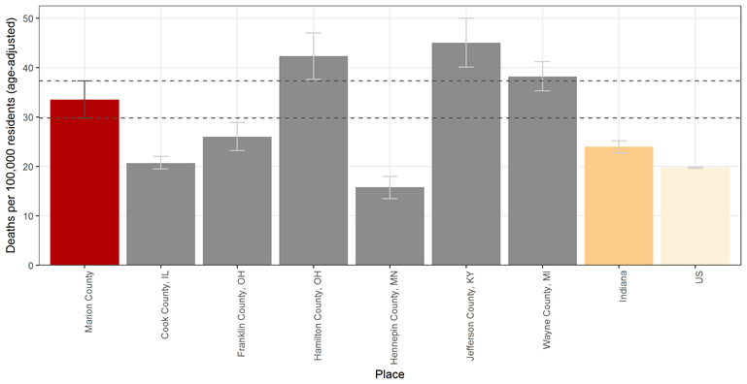  Source: CDC WONDER Fatal Drug Overdose
Treatment  - Cognitive behavioral therapy  - Motivational enhancement therapy  - Inpatient and Residential treatment or intensive outpatient treatment  - Medication Assisted Therapy  Source: WHO, Information sheet on opioid overdose | Trend  Marion Co. Overdose Deaths, 2010-2016  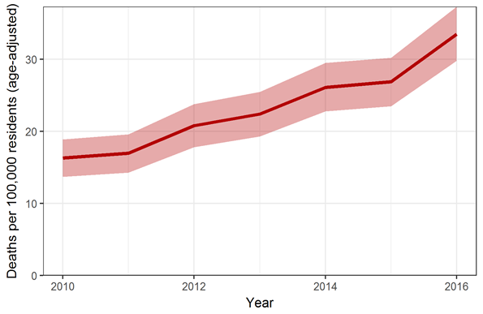  Source: CDC WONDER Fatal Drug Overdose

Risk Factors
- History of substance use disorder
- High prescribed dosage or multiple prescriptions
- Male gender or older age
- Mental health conditions
Source: WHO, Information sheet on opioid overdose & CDC, Risk Factors for Prescription Opioid Abuse and Overdose

Equity
Overdose Deaths by Drug Type, Marion Co. 2017
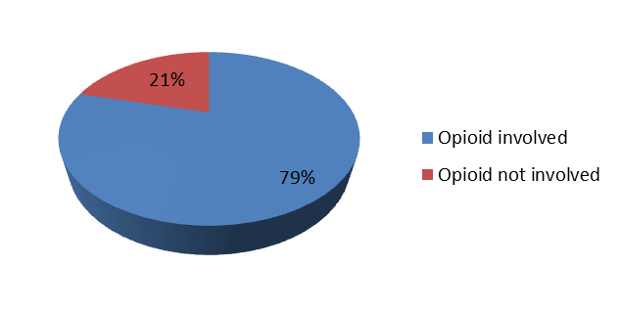
Source: Marion County Coroner’s Office Toxicology Data (of 406 overdose deaths with toxicology)
Overdose Deaths by Race/Ethnicity, Marion Co. 2010-2017  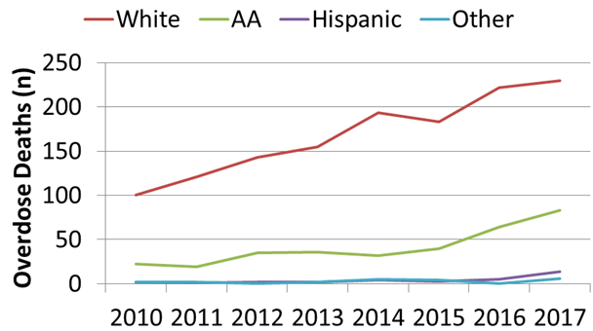  Source: Marion County Death Certificates | Overdose Deaths by Gender, Marion Co. 2013-2017  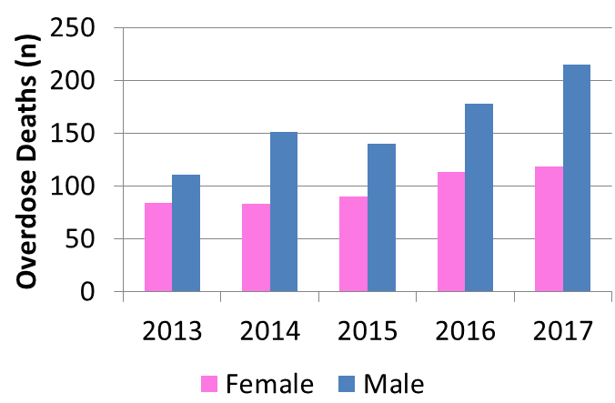  Source: Marion County Death Certificates

